CAT COMMAND

1) To view a single file Command

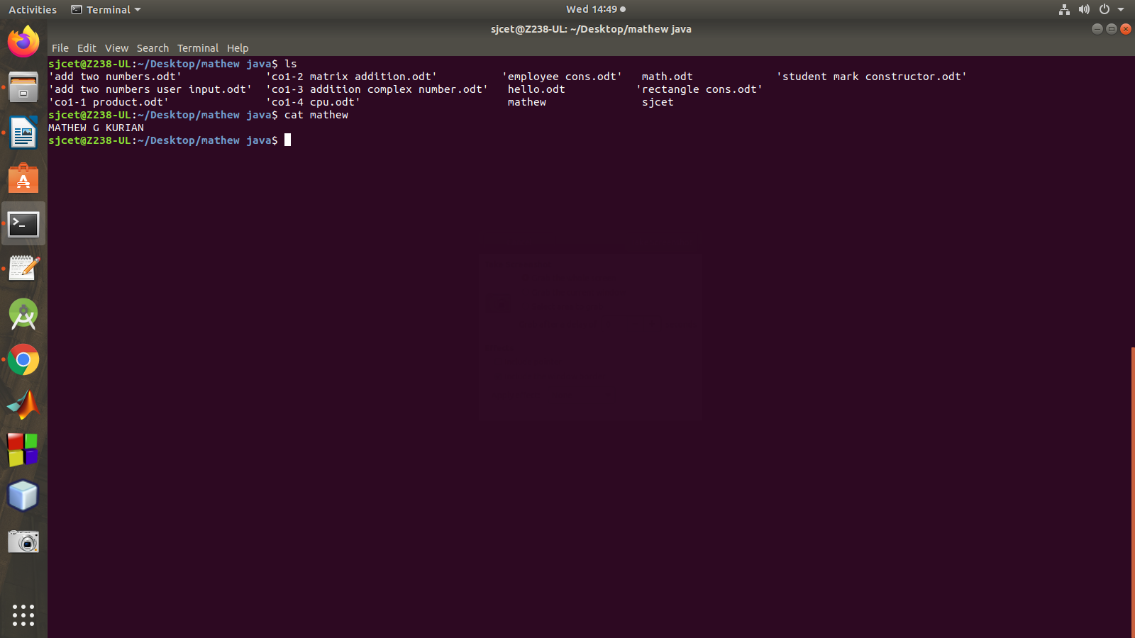
2) To view multiple files Command

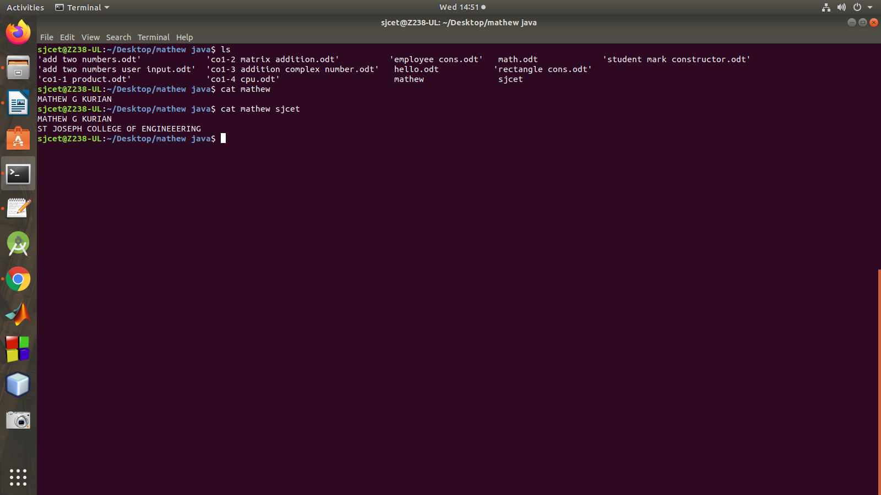
3) Create a file Command
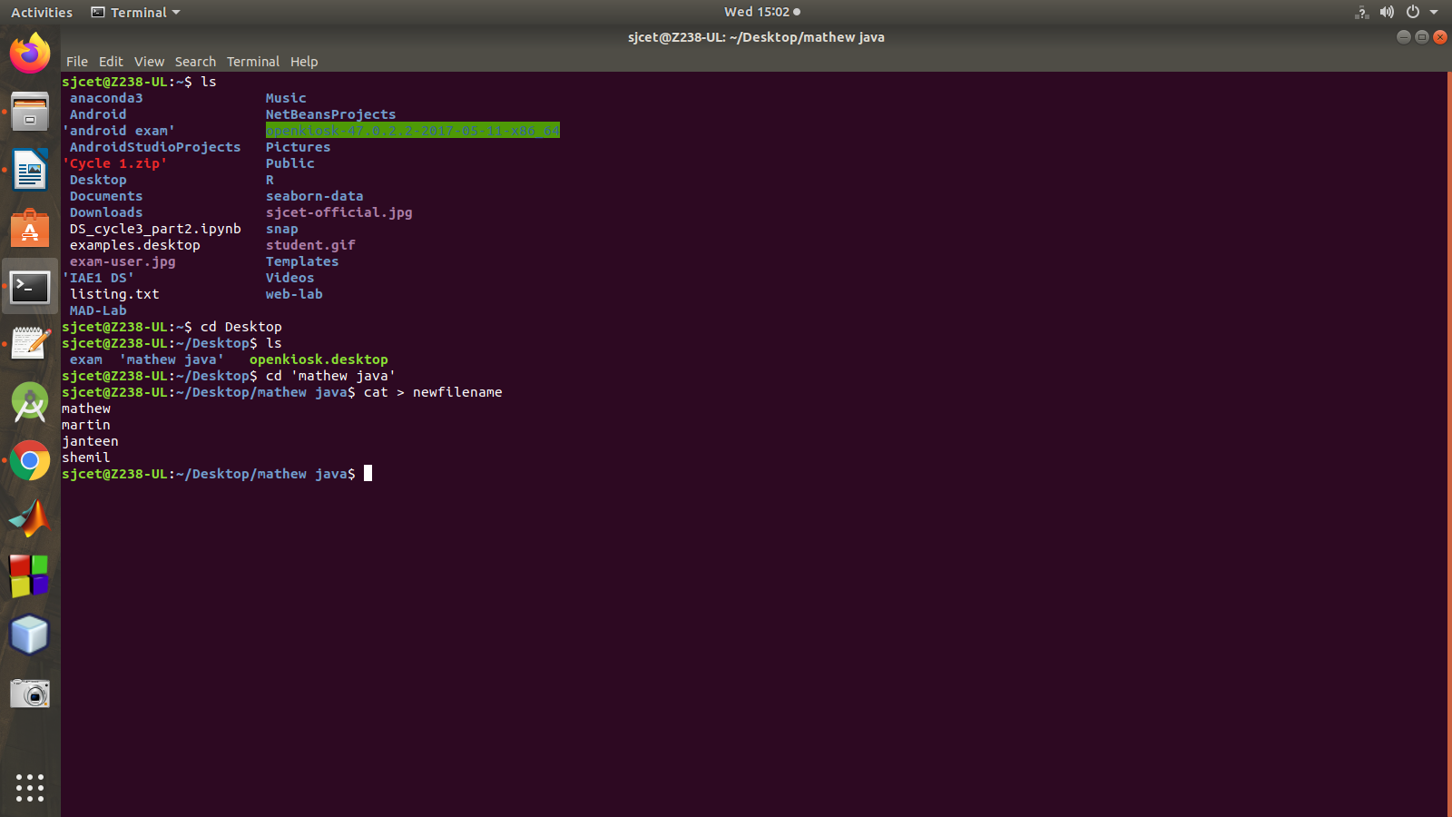
4 To view contents of a file preceding with line numbers Command

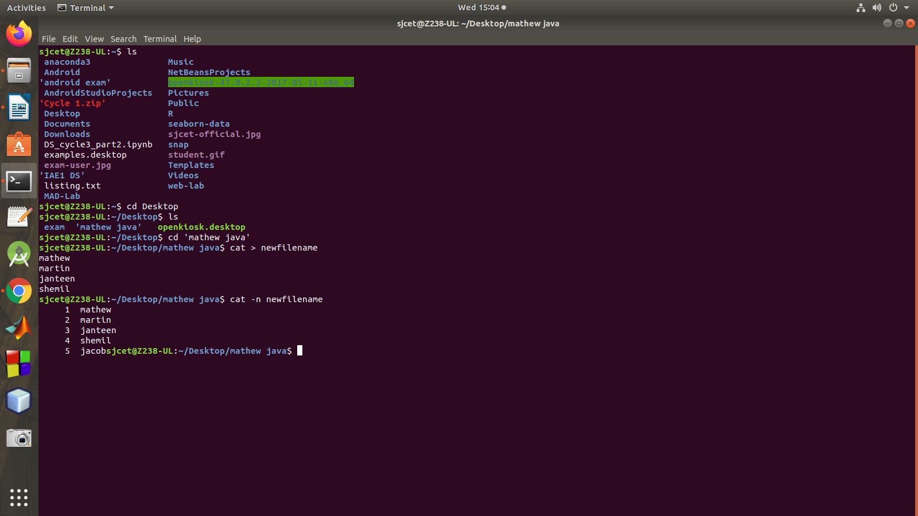

5) Copy the contents of one file to another file Command
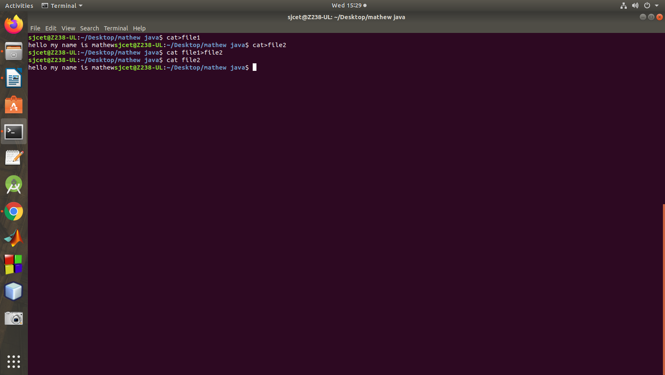
6) Cat command to append the contents of one file to the end of another file Command

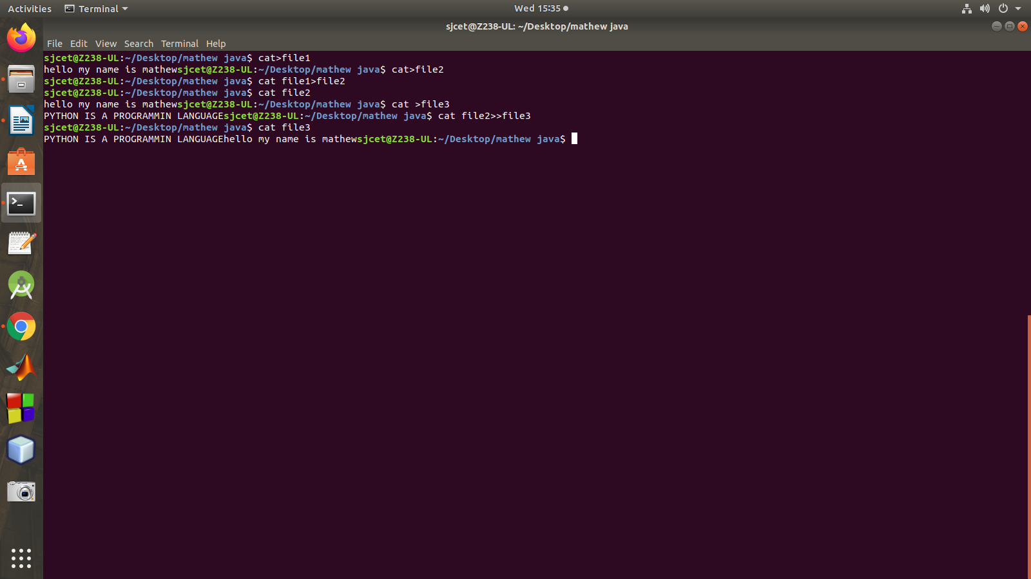

7) Cat command can display content in reverse order using tac command.

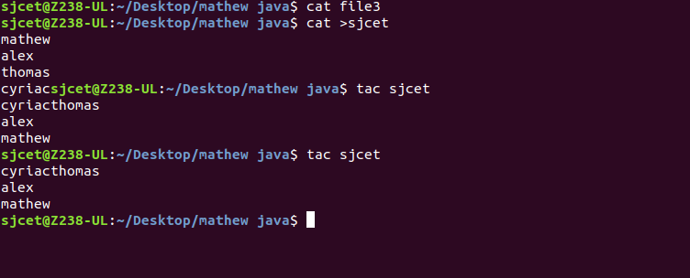
8)Suppressing Empty Lines with the Cat Command

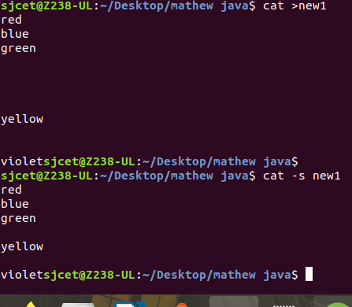

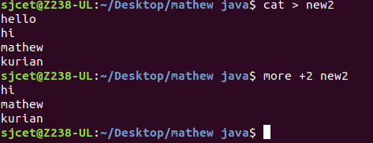
9)Cat command if the file has a lot of content and can’t fit in the terminal Command

